Lab 12 – Terraform Provisioners, Modules & Nginx Reverse Proxy/Load Balancer

LINK TO MY REPO:

emanhanif1/CC_EmaanHanif_17_Lab12

Objective
- In this lab you will:
- Use GH CLI to work inside a Codespace.
- Organize Terraform code into separate files (variables. tf, outputs.tf, locals.tf, main.tf, terraform.tfvars).
- Practice Terraform provisioners: user_data, remote-exec, file, and local-exec.
- Create reusable Terraform modules for subnet and webserver resources.
- Configure Nginx as a reverse proxy and load balancer.
- Implement SSL/TLS with self-signed certificates.
- Configure Nginx caching for improved performance.
- Implement high availability patterns with backup servers

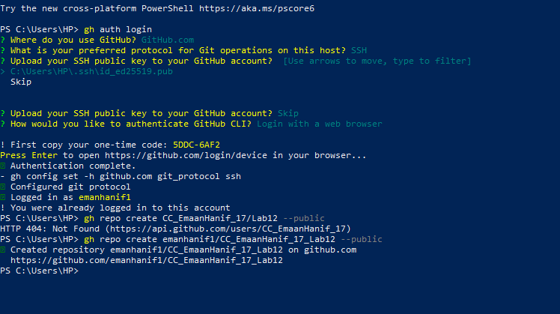

Task 0: Lab Setup (Codespace & GitHub CLI)

1. Repository Creation
- Using GitHub CLI, a new repository was created under the GitHub username emanhanif1 with the name CC_EmaanHanif_17_Lab12.
- Command used:
- gh repo create emanhanif1/CC_EmaanHanif_17_Lab12 --public
- This repository will host all lab assignments and act as the source for the Codespace.

Repository Initialization
- Codespace creation failed because the repository did not have any branch or initial commit.
- To resolve this:
  - Clone the repository locally.
  - Add a README.md file.
  - Make the initial commit.
  - Push to the main branch
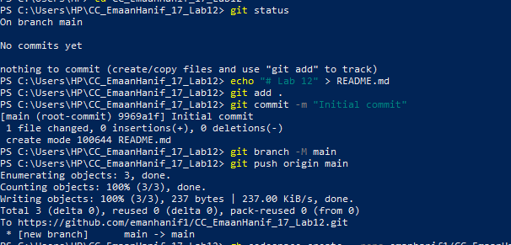

Verification and SSH Access
- Codespace list verified the Codespace creation:
gh codespace list

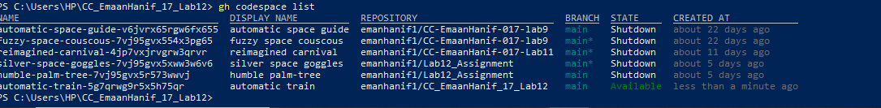

SSH into the Codespace shell:
gh codespace ssh -c <codespace_name>

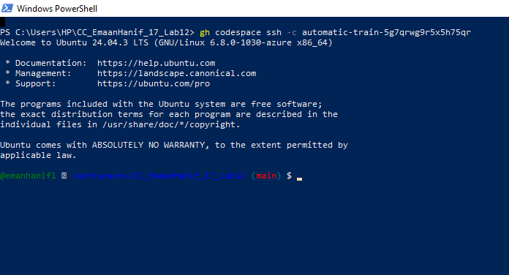
Inside the Codespace, the working directory confirmed the repository path:
pwd

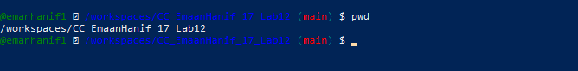

Task1- Organize Terraform code into separate files

Step 1: Create Project Directory
• Created a new project directory named Lab12 using the mkdir -p command.
• Navigated into the Lab12 directory using the cd command.
• This directory serves as the root folder for all files and configurations of the project.

Step 2: Create Terraform File Structure
# Main Terraform files

- Created Terraform configuration files (main.tf, variables.tf, outputs.tf, locals.tf) to define infrastructure resources, inputs, outputs, and local values.
- Created terraform.tfvars to store variable values separately from the main configuration.
- Created entry-script.sh to automate instance initialization tasks during deployment.

- Listed all files and directories with detailed permissions using ls -la.
- Confirmed that all required Terraform and script files were successfully created in the project directory.
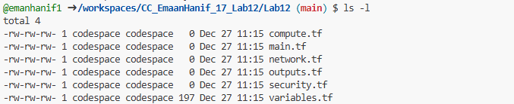
Now your Lab12 folder is ready to organize Terraform code into separate files.

2)

Add Variables to variables.tf
- Opened the variables.tf file in the project directory.
- Defined input variables for VPC CIDR, subnet CIDR, availability zone, environment prefix, instance type, and SSH keys.
- Add the following content to variables.tf

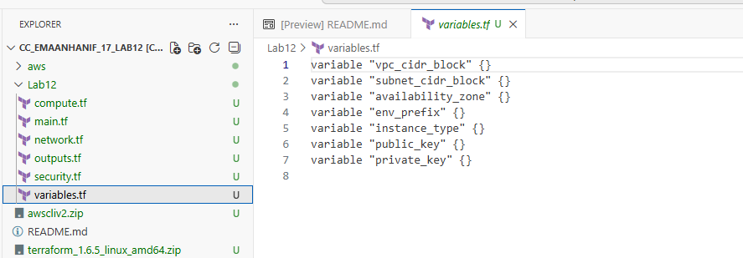

- Verify:
cat variables.tf

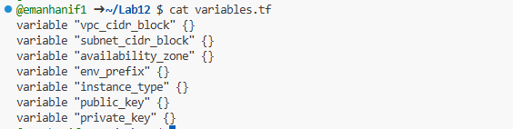
- Verified the contents of variables.tf using the cat variables.tf command to ensure all variable definitions were correctly added.

Defines all the input variables that Terraform will use for VPC, subnets, availability zone, instance type, and SSH keys.

3) Create outputs.tf with the following content:
output "aws_instance_public_ip" {
value = aws_instance.myapp-server.public_ip
}

• Opened the outputs.tf file.
• Defined an output to display the public IP address of the EC2 instance after deployment.

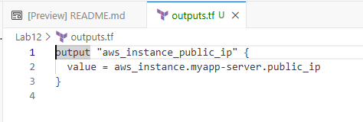
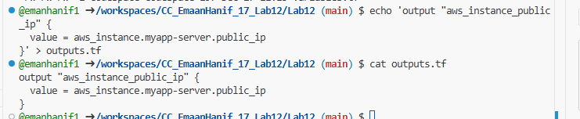
- Defines what Terraform will output after deployment.
- Here, it will display the public IP of the EC2 instance myapp-server.

locals.tf
- Created the locals.tf file in the project directory.
- Defined a local variable my_ip to automatically detect the current public IP address and append /32 for CIDR notation.
- Added an HTTP data source to fetch the public IP from an external service.

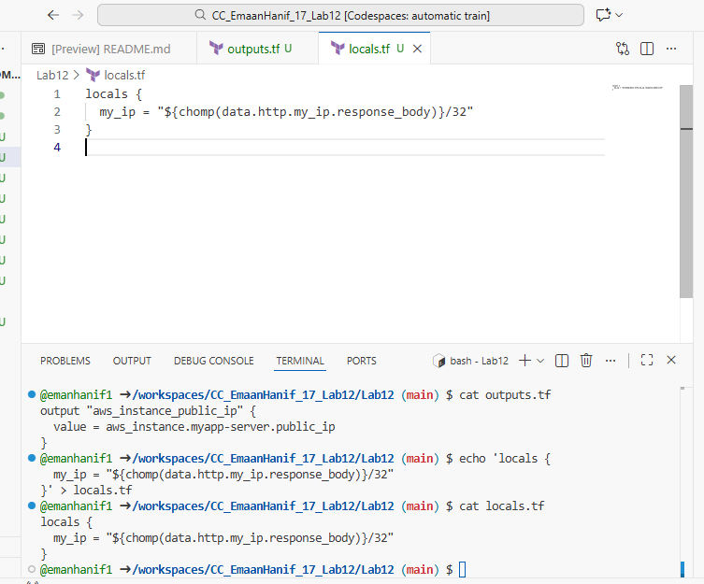

- Here, my_ip stores your current public IP (from HTTP request) with /32 CIDR, useful for security group rules.

Create terraform.tfvars

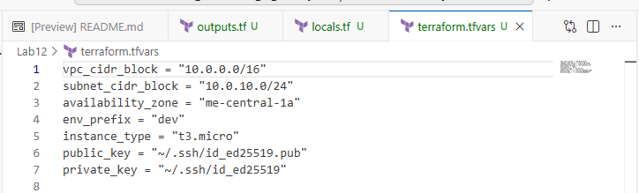
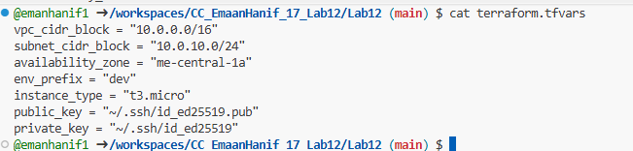
- Purpose of terraform.tfvars
  - Provides values for the variables defined in variables.tf.
  - Example:
    - vpc_cidr_block corresponds to variable "vpc_cidr_block"
    - instance_type corresponds to variable "instance_type"
- Why separate file
  - Makes it easy to change values without editing main Terraform files.
  - Terraform automatically reads this file and fills the variables when applying.
- SSH keys
  - public_key and private_key point to your local SSH key pair, used for EC2 access.

7)MAIN.TF
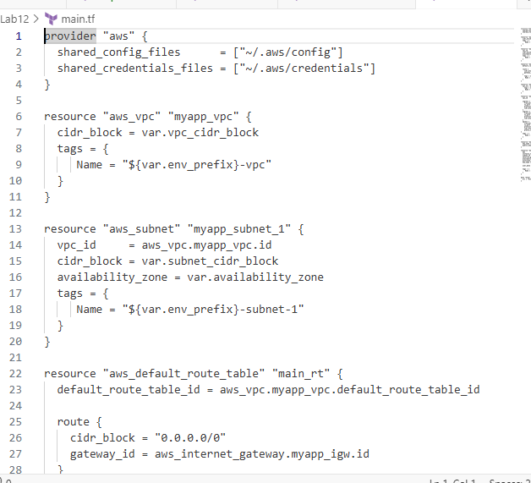

- Created the main.tf file in directory.
- Configured the AWS provider to use local AWS credentials and config files.
- Defined a VPC with a CIDR block from var.vpc_cidr_block
- Created a subnet within the VPC
- Configured a default route table with a route to the internet via an Internet Gateway.
- Created an Internet Gateway for the VPC
- Configured the default security group to allow SSH from the local IP and HTTP from all IPs, with unrestricted egress.
- Added an AWS key pair using the public key file for SSH access.
- Created an EC2 instance

Verify content
cat main.tf
Output should display the full content of main.tf.

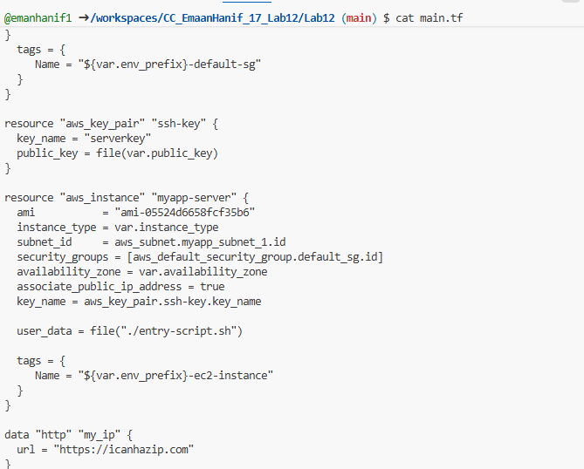

- provider "aws"
  - Specifies AWS credentials and config files.
- aws_vpc
  - Creates a VPC where all resources will reside.
- aws_subnet
  - Creates a subnet inside the VPC.
- aws_internet_gateway & default route table
  - Provides internet access for the VPC.
- aws_default_security_group
  - Defines security rules:
    - SSH (port 22) from your current IP
    - HTTP (port 80) open to all
  - Uses local.my_ip for dynamic IP.
- aws_key_pair
  - Defines SSH key for EC2 access.
- aws_instance
  - Creates an EC2 instance with public IP, security groups, and user_data script.
- data "http" "my_ip"
  - Fetches your current public IP dynamically.

Summary
- main.tf contains all core resources and provider configuration.
- Other files (network.tf, compute.tf, security.tf) can later be used to split resources for organization.

8)
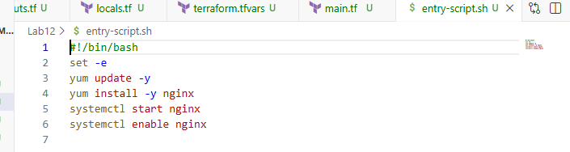
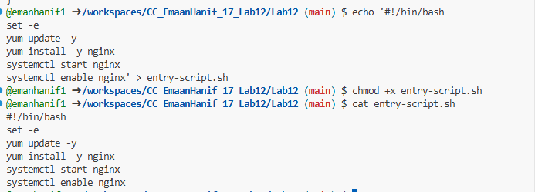
- #!/bin/bash
  - Tells the system that this is a bash script.
- set -e
  - Stops the script if any command fails.
- yum update -y
  - Updates all packages automatically.
- yum install -y nginx
  - Installs nginx web server without asking confirmation.
- systemctl start nginx
  - Starts the nginx service immediately.
- systemctl enable nginx
  - Ensures nginx starts automatically on instance boot.
Why: This script runs when EC2 instance launches (user_data). It automatically sets up nginx, so the instance is ready without manual intervention.

9) Generate SSH key pair if not already exists:

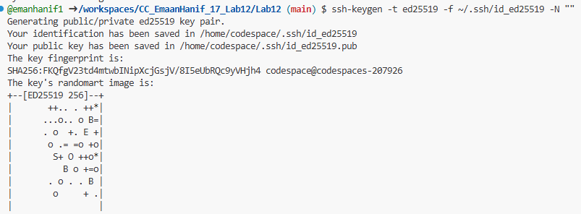

- ssh-keygen
  - Generates a secure key pair for SSH login.
- -t ed25519
  - Uses ed25519 algorithm (modern and secure).
- -f ~/.ssh/id_ed25519
  - Saves the key in .ssh folder as id_ed25519 (private) and id_ed25519.pub (public).
- -N ""
  - No passphrase, login will be automatic with the key.

PURPOSE
- EC2 instances require SSH keys for login.
- Public key is added to the instance (aws_key_pair resource).
- Private key stays with you → you use it to login securely.
9)

1. Initialize Terraform
- Generate SSH key pair if not already exists:
terraform init

What it does:
- Downloads provider plugins (AWS in this case).
- Prepares the folder for Terraform execution.
- Checks the configuration files for syntax errors.
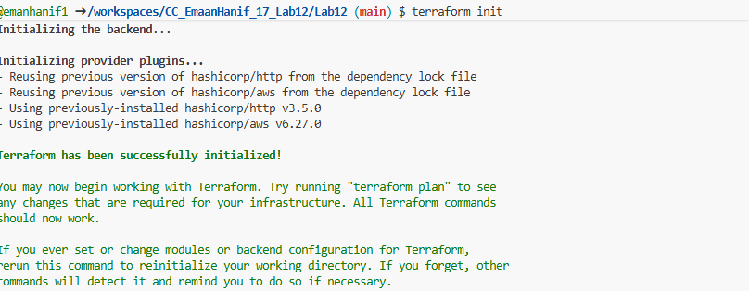
Screenshot should show Terraform initialization success.

2. Apply Terraform Configuration

Command:
terraform apply -auto-approve
- -auto-approve → applies configuration without asking confirmation.

What it does:
- Terraform reads all .tf files (main.tf, variables.tf, etc.)
- Creates all resources on AWS:
  - VPC, Subnet, Internet Gateway
  - Security Group, Key Pair
  - EC2 Instance with nginx installed
- Uses terraform.tfvars for variable values.

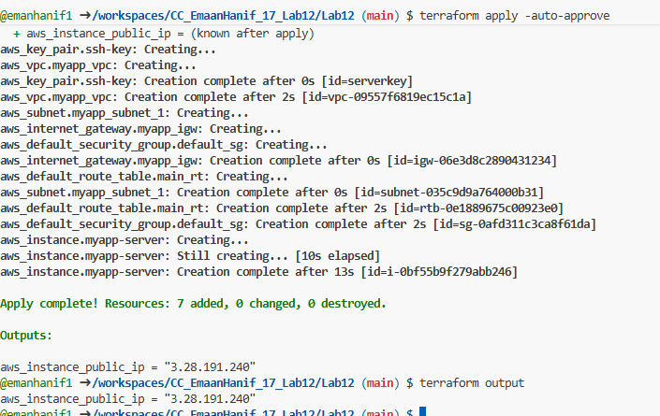
Screenshot should show resources being created and applied successfully.

3. Display Terraform Output

Command:
terraform output

What it does:
- Shows values defined in outputs.tf
- Example: aws_instance_public_ip → public IP of EC2 instance.
📸 Screenshot name:
task1_terraform_output.png
Screenshot should show EC2 public IP returned by Terraform.

Test Nginx in Browser
- Get the public IP of your EC2 instance
terraform output

- Open browser → navigate to:
http:3.28.191.240
- Replace <public-ip> with the value from Terraform output.
- You should see the default Nginx page.
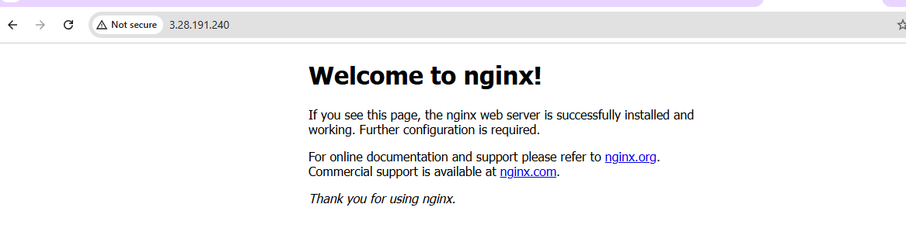 Screenshot should show the Nginx welcome page in your browser.

Destroy resources
- Command:
terraform destroy
- Confirm destruction
- Type yes when prompted.
- Terraform will delete all AWS resources it created:
  - EC2 instance
  - VPC, Subnet, Internet Gateway
  - Security Group
  - Key Pair
- Verify destruction
- After completion, Terraform shows “Destroy complete”.
- You can also check AWS console → no resources left from this Terraform run.

Summary
- terraform output → get public IP.
- Open browser → test Nginx is running.
- terraform destroy → clean up all resources.
Always destroy resources after testing to avoid AWS charges.

Task 2: Use Remote-Exec Provisioner

Step 1: Modify main.tf

What to do:
- Replace the user_data line in your aws_instance resource with a remote-exec provisioner and connection block.

Example aws_instance block:
resource "aws_instance" "myapp-server" {
ami = "ami-05524d6658fcf35b6"
instance_type = var.instance_type
subnet_id = aws_subnet.myapp_subnet_1.id
security_groups = [aws_default_security_group.default_sg.id]
availability_zone = var.availability_zone
associate_public_ip_address = true
key_name = aws_key_pair.ssh-key.key_name

connection {
type = "ssh"
user = "ec2-user"
private_key = file(var.private_key)
host = self.public_ip
}

provisioner "remote-exec" {
inline = [
"sudo yum update -y",
"sudo yum install -y nginx",
"sudo systemctl start nginx",
"sudo systemctl enable nginx"
]
}

tags = {
Name = "${var.env_prefix}-ec2-instance"
}
}

Apply the configuration

Command:
terraform apply -auto-approve

What it does:
- Terraform creates the EC2 instance (if not already created).
- Uses SSH connection to run commands in inline array:
  - Updates OS packages
  - Installs nginx
  - Starts and enables nginx service
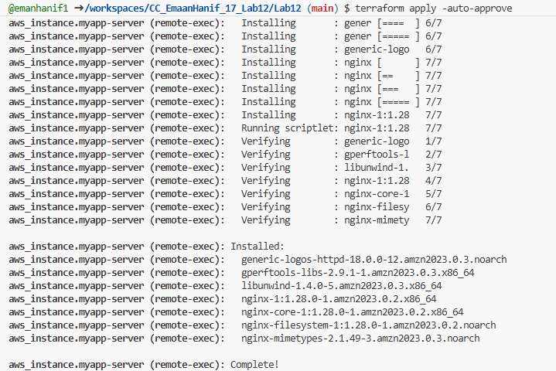
task2_terraform_apply.png
Screenshot should show remote-exec commands executing successfully.

Step 3: Display Terraform Output

Command:
terraform output
- Shows EC2 public IP just like Task 1.
📸 Screenshot name:
task2_terraform_output.png

Step 4: Test Nginx in Browser
- Open browser → navigate to:
- http://51.112.51.58
- Should display Nginx default page.
📸 Screenshot name:
task2_nginx_browser.png
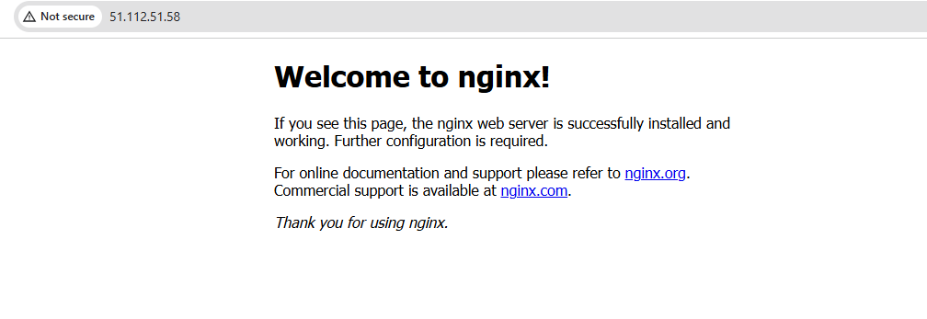

Explanation
- remote-exec vs user_data
  - user_data runs only once at instance launch
  - remote-exec runs via SSH from Terraform, can run on existing instances
- connection block
  - Defines how Terraform connects to EC2 via SSH
  - Uses your private key and instance public IP
- inline commands
  - Executes commands directly on the EC2 instance
  - Same as running commands manually after SSH
- Benefit
  - More flexible → can update or configure existing instance

Task3- Use file and local-exec provisioners

Modify aws_instance resource
Replace the previous remote-exec block with all three provisioners:
- file → Copies entry-script.sh from your machine to the EC2 instance.
- remote-exec → Runs the script on EC2 (install nginx, start service).
- local-exec → Prints/logs the EC2 instance ID and public IP on your local machine.

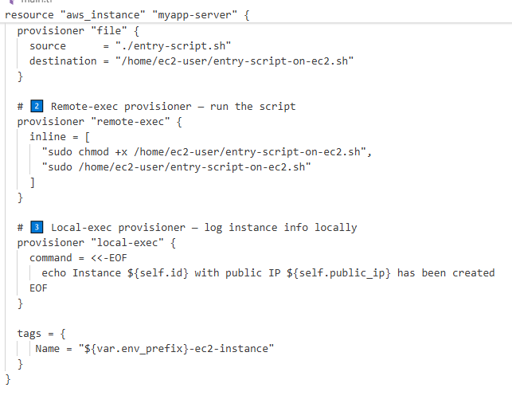

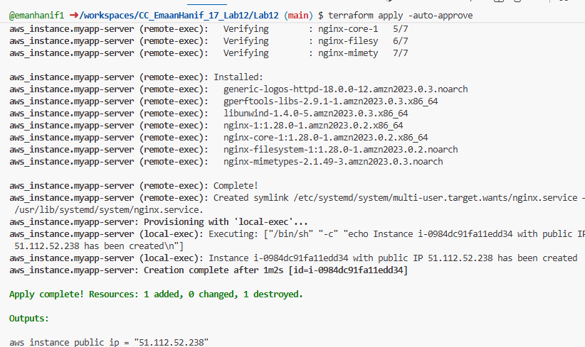
• Terraform created and provisioned all defined resources automatically without prompting for approval.
• Monitored the output to ensure all resources, including VPC, subnet, security group, key pair, internet gateway, and EC2 instance, were successfully created.

Display output
terraform output
- Shows public IP of the EC2 instance.

Confirmed that the EC2 instance was successfully provisioned and accessible via the retrieved public IP.

Test Nginx
- Open browser:
http://<public-ip>
- Replace <public-ip> with the 51.112.52.238
- You should see the Nginx default page.

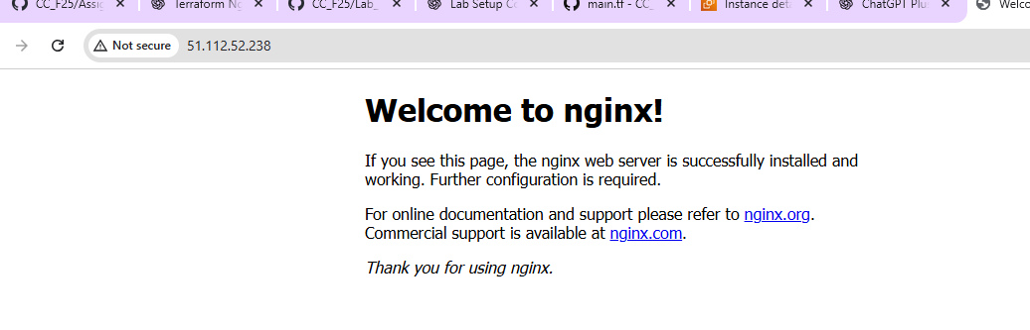

Destroy resources
terraform destroy
- Type yes when prompted.
- Deletes all AWS resources created in this task.

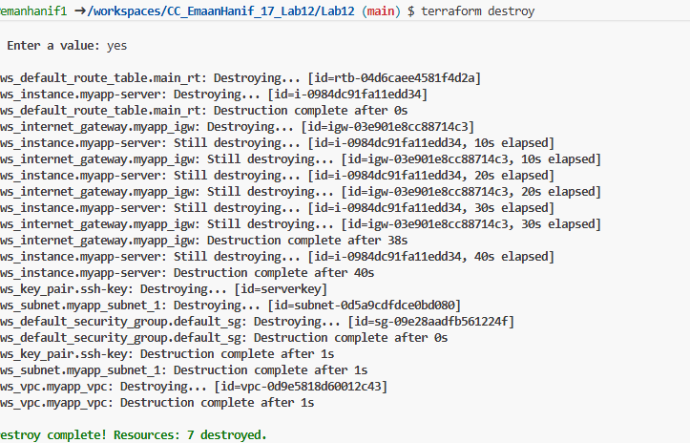

Bottom of Form

Restore user_data in main.tf
After using file, remote-exec, and local-exec provisioners, the last step is to simplify your EC2 resource back to the original user_data approach.

Edit main.tf
- Open main.tf.
- Remove these blocks from aws_instance:
- connection { … }

- provisioner "file" { … }

- provisioner "remote-exec" { … }

- provisioner "local-exec" { … }
- Replace them with:
- user_data = file("./entry-script.sh")
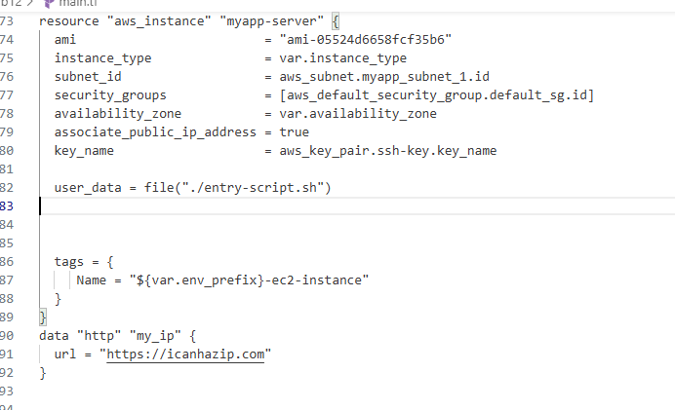
- It should clearly show user_data restored and no connection/provisioner blocks.

Task 4 — Create Terraform Subnet Module
The goal: Make a reusable subnet module so your infrastructure code is organized and can be reused for multiple subnets.

Create module directory structure
In your Lab12 workspace:
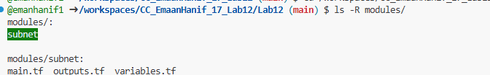
- modules/subnet/main.tf → resource definitions (subnet creation).
- modules/subnet/variables.tf → variables the module accepts.
- modules/subnet/outputs.tf → outputs the module returns (e.g., subnet ID)

Verify structure
Or, if tree is installed:
tree modules/

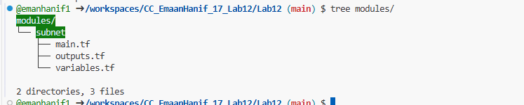
- Screenshot required:
task4_module_structure.png

Why use a module?
- Reusability: You can create multiple subnets without repeating code.
- Organization: Keeps main.tf clean.
- Maintainability: Any change to subnet logic is done in one place.

2) Create modules/subnet/variables.tf:
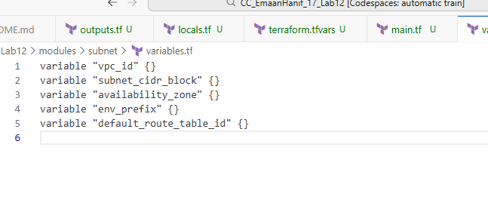 variables.tf defines all the inputs that your subnet module will need.
- Instead of hardcoding values, you pass them from the root main.tf when you call the module.
Variable | Purpose
vpc_id | The VPC where the subnet will be created
subnet_cidr_block | CIDR block for this subnet (like 10.0.10.0/24)
availability_zone | Which AZ the subnet will be in
env_prefix | Prefix for naming the subnet (like dev or prod)
default_route_table_id | ID of the default route table to attach routes

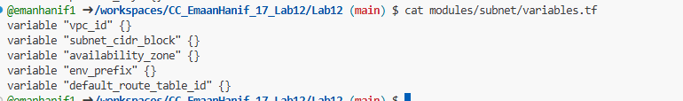

You can view file content from anywhere using cat or echo like this\

Purpose:
- These variables make the module reusable for different VPCs, CIDRs, and environments.
- The root module will pass values for these variables.

- Create modules/subnet/main.tf:

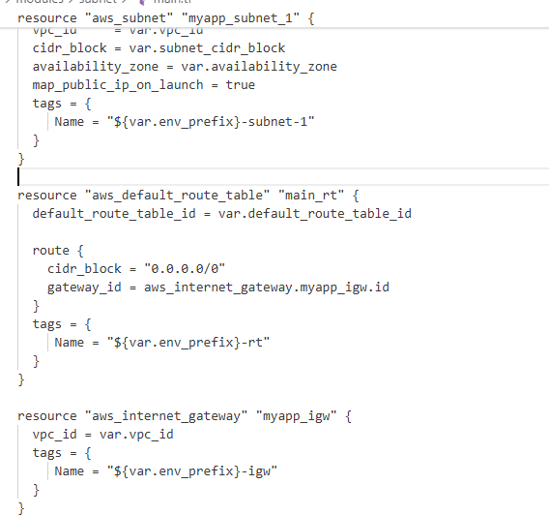

Creates a subnet, internet gateway, and route table inside the module.
Module handles network setup automatically.

- Create modules/subnet/outputs.tf:

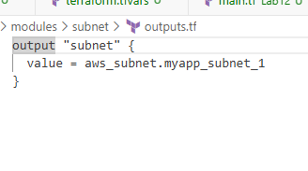
Exposes the subnet ID so root main.tf can use it for EC2 instances.

Update Root main.tf
- Remove subnet, route table, and IGW resources from root.
- Add module call:
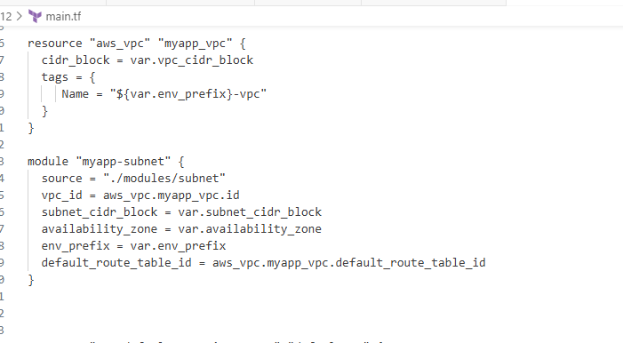 Update EC2 instance to use module output:

Purpose:
  - Root main.tf is now clean and modular.
  - EC2 instance automatically uses subnet from module.
- Screenshot: task4_main_tf_with_module.png

Initialize Terraform
terraform init

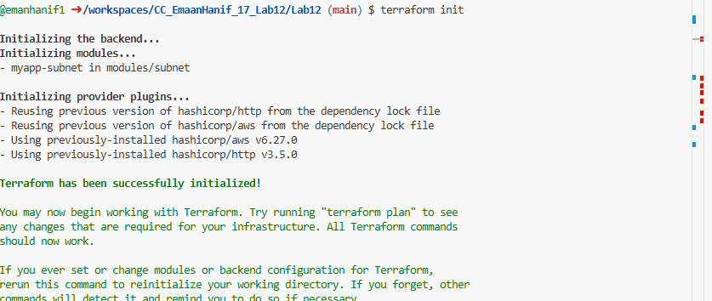

Downloads modules and providers.
  - Must run before apply after adding a new module.
- Screenshot: task4_terraform_init.png

Apply the Configuration
terraform apply -auto-approve

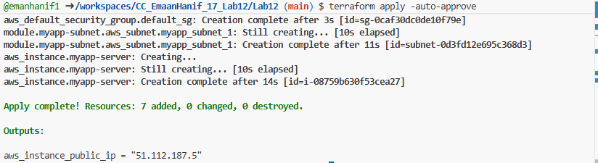
- Terraform creates:
  - VPC
  - Subnet, IGW, route table (via module)
  - Security group
  - EC2 instance
- Screenshot: task4_terraform_apply.png

View Outputs
terraform output
- Shows the public IP of your EC2 instance.

- Test nginx in browser:
- Open browser and navigate to http://<public-ip>

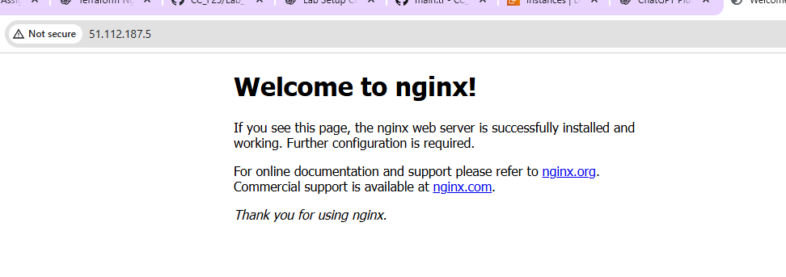

Task5- Create webserver module

Create Webserver Module Directory

Purpose
- modules/webserver/ → module folder
- main.tf → EC2, security group, key pair
- variables.tf → inputs from root module
- outputs.tf → values returned to root (like public IP)

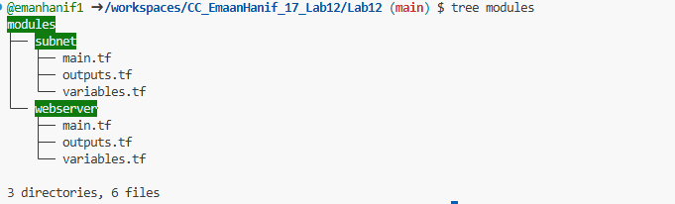

Define Module Variables
modules/webserver/variables.tf

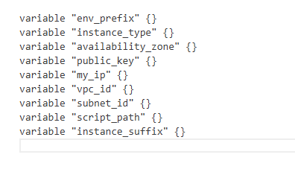

Step 3 — Create EC2 + SG + Key in Module
modules/webserver/main.tf:
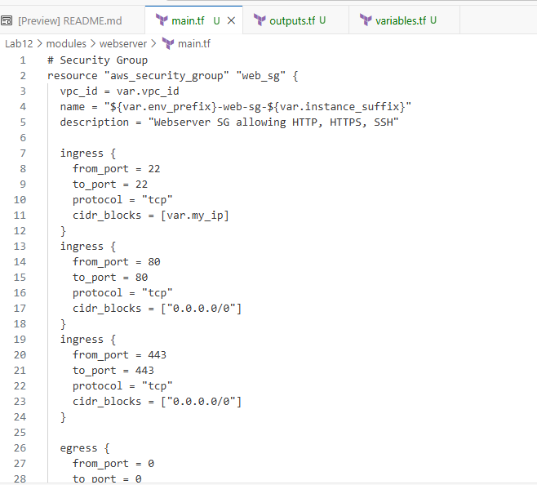

Step 4 — Module Outputs
modules/webserver/outputs.tf:
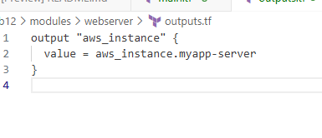

In the root main.tf file:

Remove the following resources (if they exist):
- aws_security_group
- aws_key_pair
- aws_instance
These resources are now handled inside the webserver module, so they should not be in the root file anymore.

Add the webserver module block
Paste the following code into your root main.tf:
module "myapp-webserver" {
source = "./modules/webserver"

env_prefix = var.env_prefix
instance_type = var.instance_type
availability_zone = var.availability_zone
public_key = var.public_key
my_ip = local.my_ip
vpc_id = aws_vpc.myapp_vpc.id
subnet_id = module.myapp-subnet.subnet.id
script_path = "./entry-script.sh"
instance_suffix = "0"
}

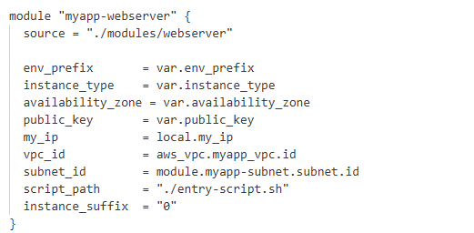

- Update outputs.tf:
output "webserver_public_ip" {
value = module.myapp-webserver.aws_instance.public_ip
}
- Save screenshot as: task5_outputs_updated.png — updated outputs.tf.

- Initialize Terraform:
terraform init
- Save screenshot as: task5_terraform_init.png — terraform init output.
- Apply the configuration:
terraform apply -auto-approve
- Save screenshot as: task5_terraform_apply.png — terraform apply output with webserver module.

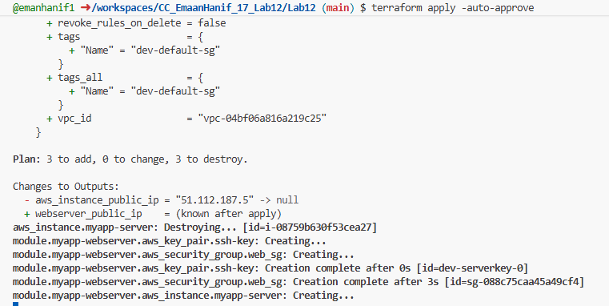

- Update outputs.tf:
output "webserver_public_ip" {
value = module.myapp-webserver.aws_instance.public_ip
}

- Display the output:
terraform output
- Save screenshot as: task5_terraform_output.png — terraform output showing webserver public IP.
- Test nginx in browser:
- Open browser and navigate to http://<public-ip>
- Save screenshot as: task5_nginx_browser.png — browser showing nginx default page.
.

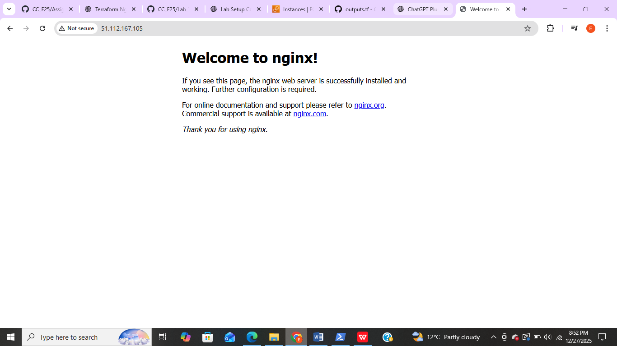

Terraform destroy

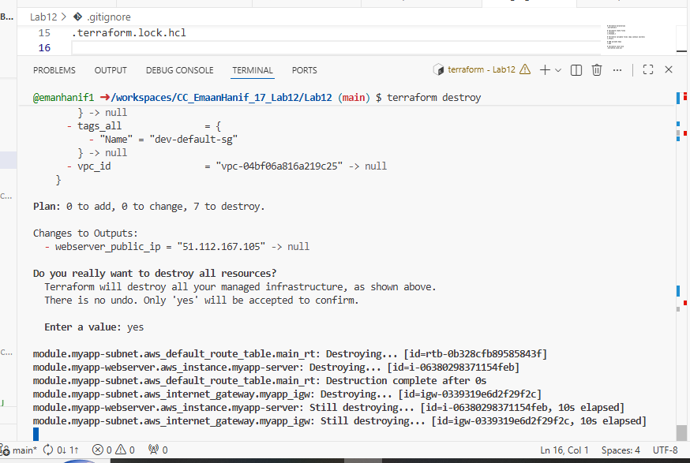

Task 6 — Configure HTTPS with Self-Signed Certificates

Update entry-script.sh
Replace your old script or append the HTTPS configuration with the following key points:

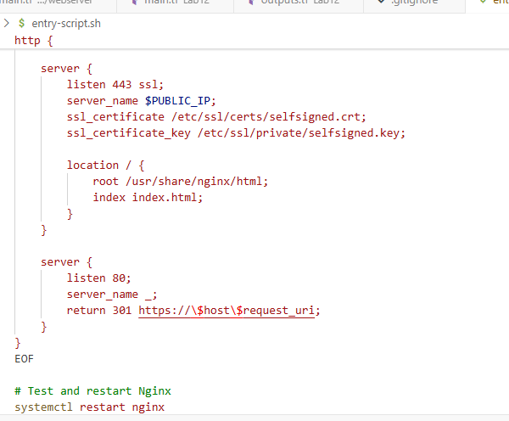

- IMDSv2 token → securely fetch EC2 metadata (IP/hostname)
- Self-signed cert → HTTPS without buying a certificate
- Dynamic CN / SAN → certificate matches the public IP
- Nginx config →
- Port 443 for HTTPS
- Port 80 redirects to HTTPS
- Optional upstream backend for load balancing
- systemctl restart nginx → apply new SSL configuration

Step 1 — Apply Terraform configuration
terraform apply -auto-approve
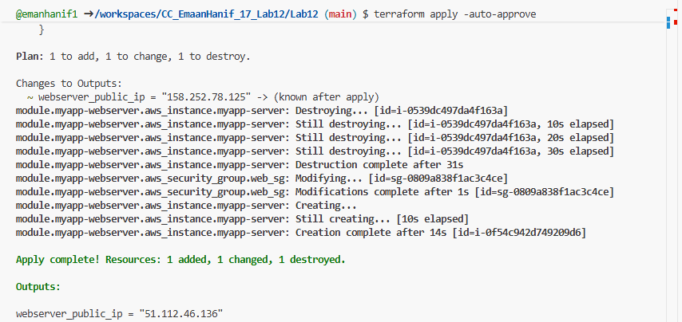
- This will create the EC2 instance with HTTPS-ready Nginx
- Screenshot: task6_terraform_apply.png

Step 2 — Display Terraform outputs
terraform output
- Copy the public IP of the webserver
- Screenshot: task6_terraform_output.png

Step 3 — Test HTTPS in browser
- Open browser
- Navigate to:
https://<public-ip>
- Browser will show:
Warning: Potential Security Risk Ahead
- Click Advanced → Accept the Risk and Continue
- Screenshot: task6_browser_security_warning.png
- 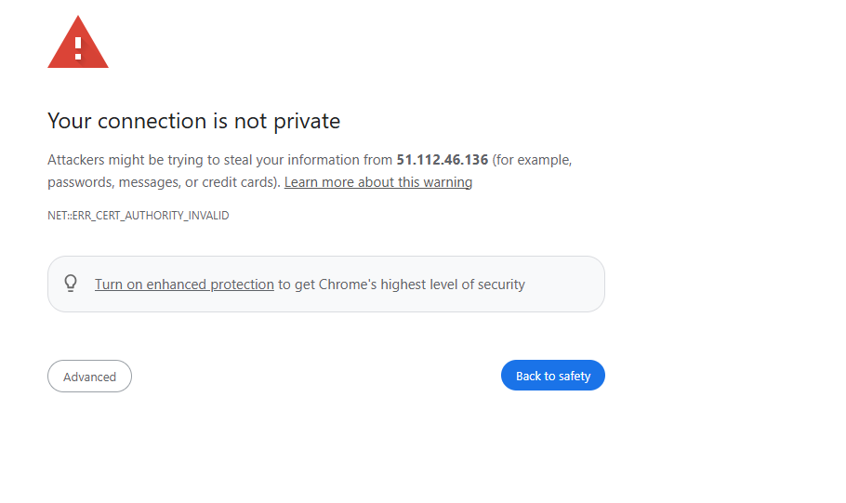
- After accepting, Nginx default page over HTTPS will load

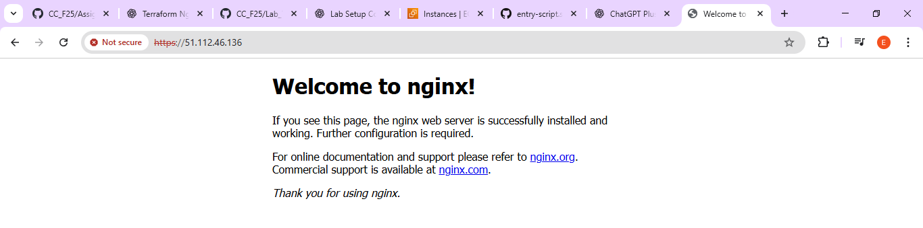
- Screenshot: task6_nginx_https_browser.png

Step 4 — Verify HTTP to HTTPS redirect
- Open browser
- Navigate to:
http://<public-ip>
- Confirm it automatically redirects to:
https://<public-ip>

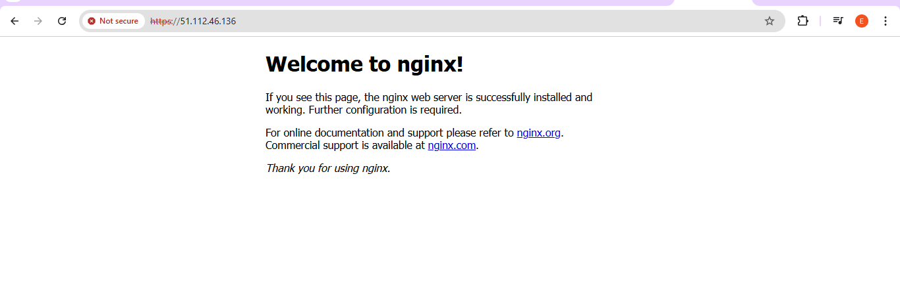
- Screenshot: task6_http_redirect.png

Task7-Configure Nginx as reverse proxy

Configure Nginx as Reverse Proxy

Step 1 — Create backend script (apache.sh)
This script will configure a backend web server (Apache) with dynamic metadata info:
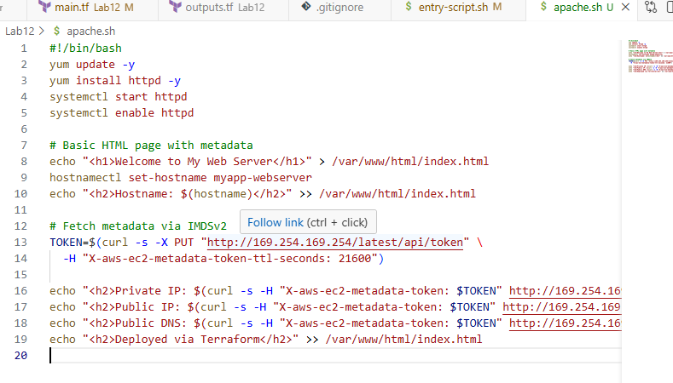

Add backend web server module in main.tf
Add a new module block for myapp-web-1:
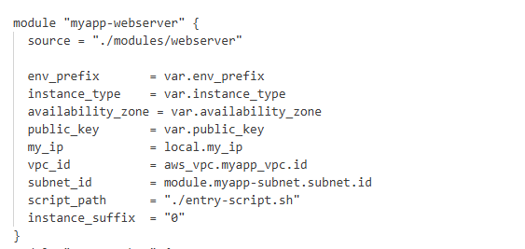

Update outputs.tf
Expose the backend web server’s public IP:

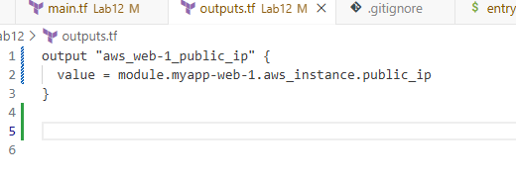
- Apply the configuration:
terraform apply -auto-approve
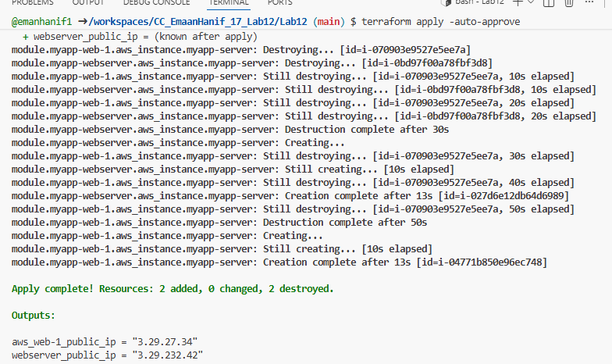
- Save screenshot as: task7_terraform_apply.png — terraform apply output showing both instances created.

SSH into the main webserver
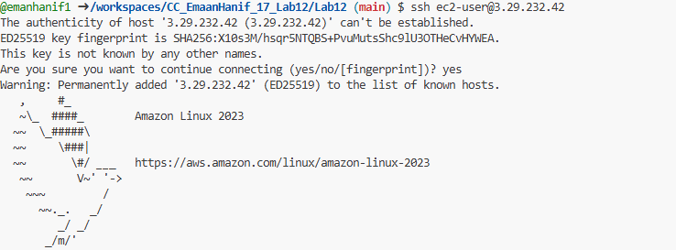

— Verify connection
Once connected, you should see something like:
[ec2-user@ip-3-29-232-42 ~]$
- This means you are now inside the webserver
- Open Nginx config
- sudo vim /etc/nginx/nginx.conf

- Step 3 — Modify the location / block
- Find the block:

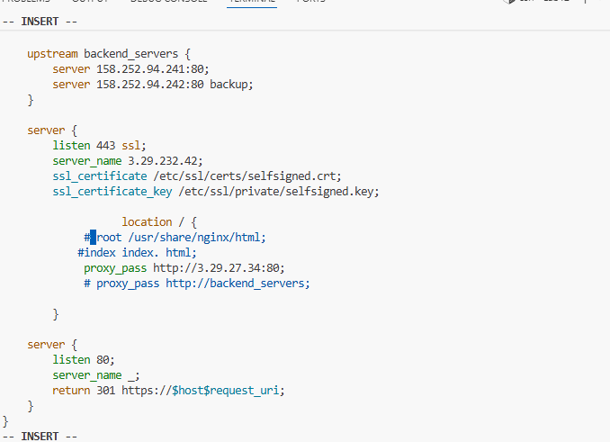

- Comment out the old root and index lines
- Replace <web-1-public-ip> with actual backend IP (3.29.27.34)

Test configuration

Reload Nginx

Now HTTPS + reverse proxy + HTTP→HTTPS redirect should work perfectly.

View Nginx logs
cat /var/log/nginx/error.log
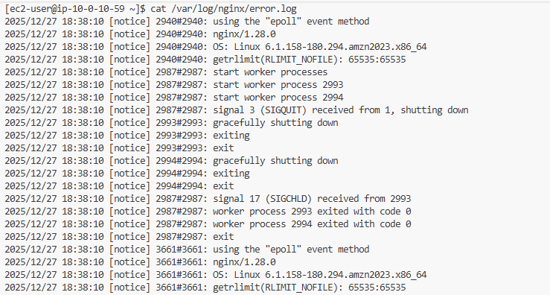
- Screenshot: task7_error_log.png
cat /var/log/nginx/access.log

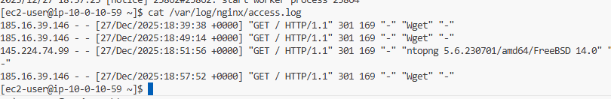
- Screenshot: task7_access_log.png

2️⃣ View configuration files
cat /etc/nginx/mime.types

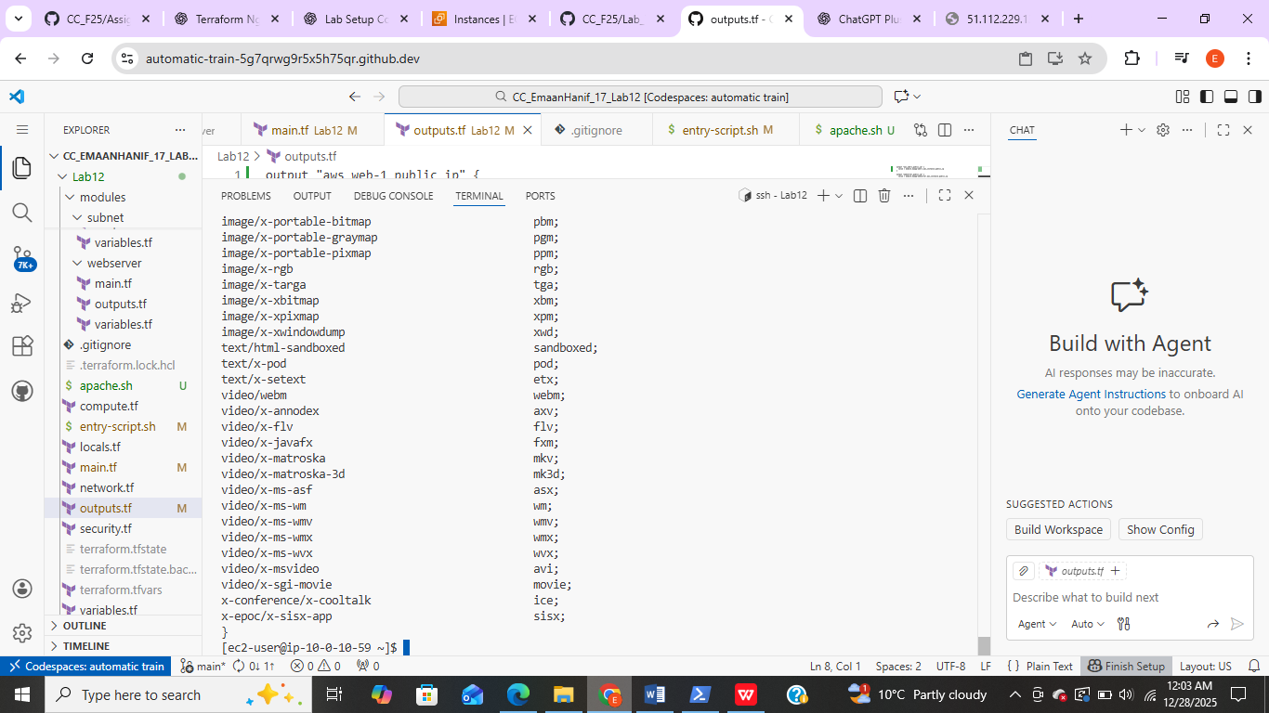
- Screenshot: task7_mime_types.png
cat /etc/ssl/certs/selfsigned.crt
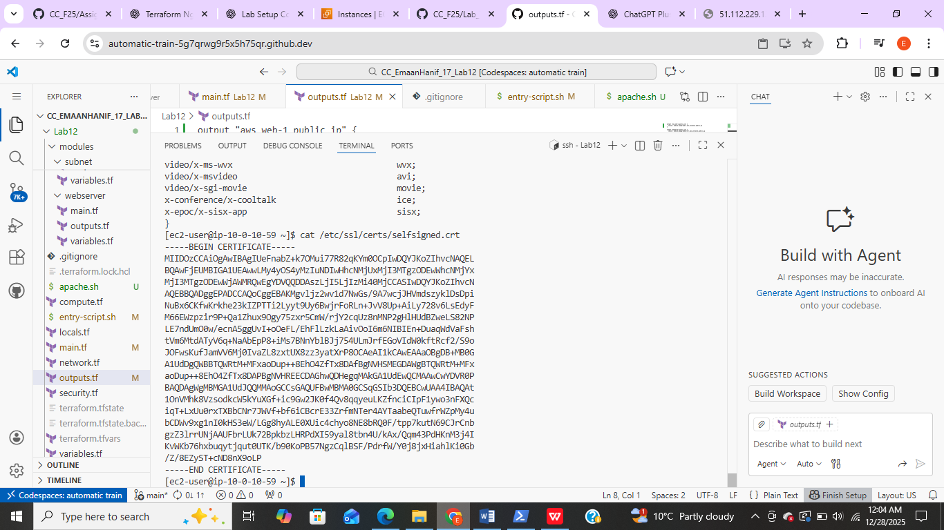
- Screenshot: task7_ssl_cert.png
Sudo cat /etc/ssl/private/selfsigned.key

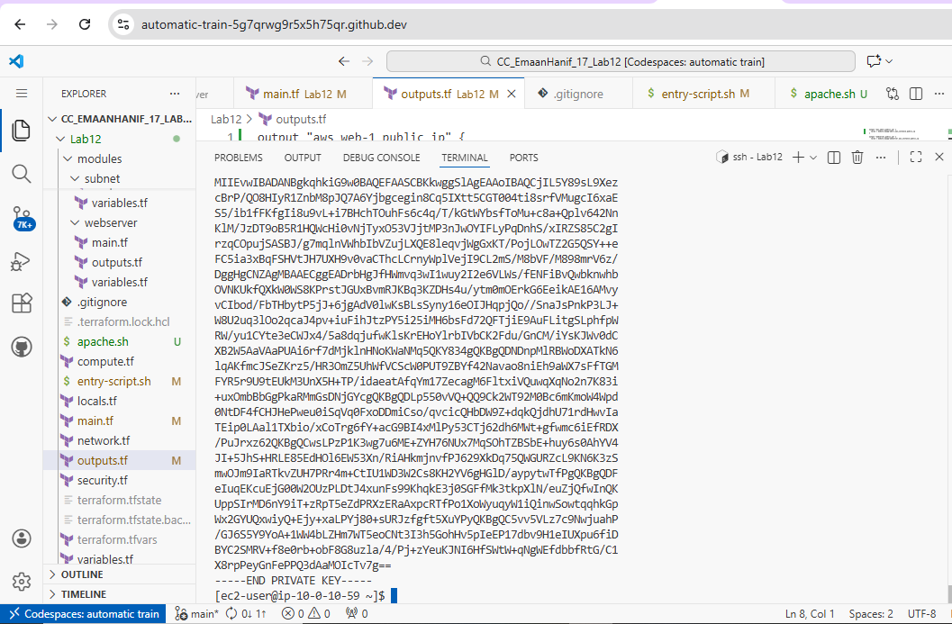
- Screenshot: task7_ssl_key.png

Test reverse proxy in browser
- Open browser → https://3.29.232.42 (your main webserver IP)
- Accept self-signed certificate warning
- You should see Apache page from backend web-1
- Screenshot: task7_reverse_proxy_browser.png
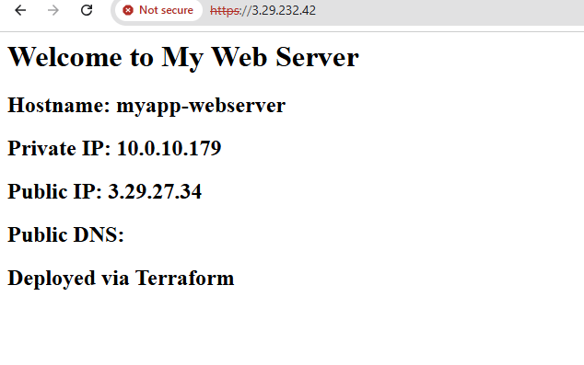

Task8-Configure Nginx as load balancer

- Add second backend server
  - In main.tf, create a new module myapp-web-2 just like myapp-web-1 but with instance_suffix = "2"
  - This launches a second EC2 running Apache.

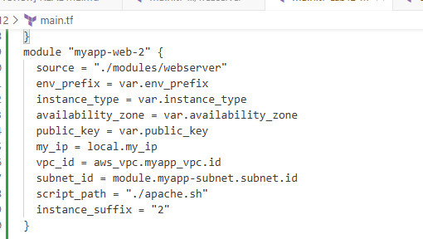

Update outputs.tf
- Add output for the new web-2 public IP:

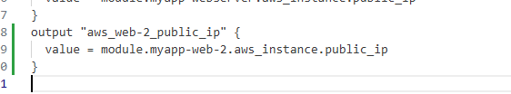

Terraform commands to run
# Initialize Terraform
terraform init

# Apply changes (creates web-2 and updates outputs)
terraform apply -auto-approve

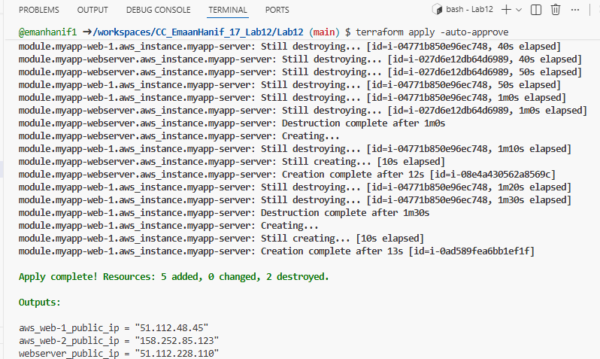
- Screenshot: task8_terraform_apply.png
terraform output
- Screenshot: task8_terraform_output.png
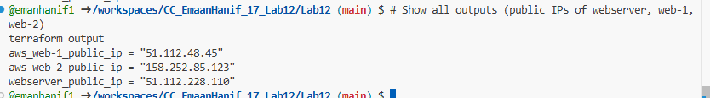

SSH into Nginx webserver
ssh ec2-user@<webserver-public-ip>

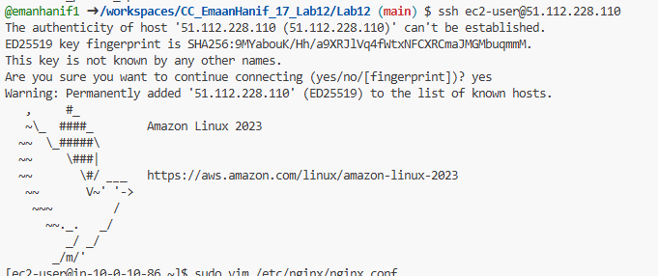

Edit Nginx configuration
sudo vim /etc/nginx/nginx.conf

Replace placeholders with your real public IPs:

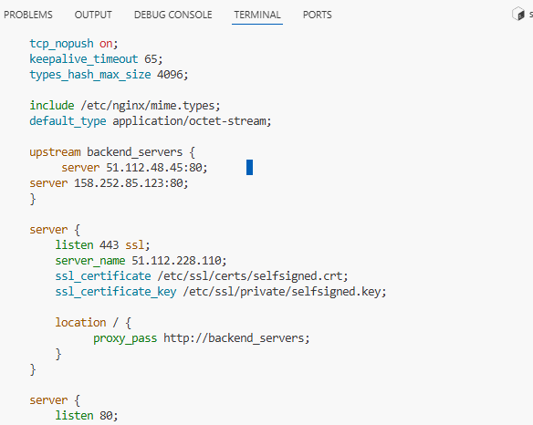

Update location block
Make sure your location / points to backend_servers:
location / {
proxy_pass http://backend_servers;
}
- Remove any old proxy_pass lines like proxy_pass http://<web-1-public-ip>:80;

Test and restart Nginx
sudo nginx -t # test configuration

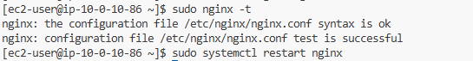

sudo systemctl restart nginx
- If syntax is correct, Nginx will reload.

Test in browser
- Open https://<webserver-public-ip>
- Reload several times → should alternate between web-1 and web-2 content.

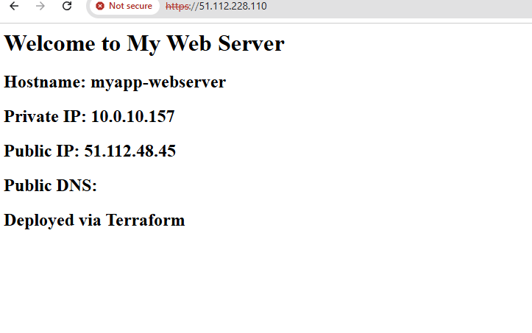

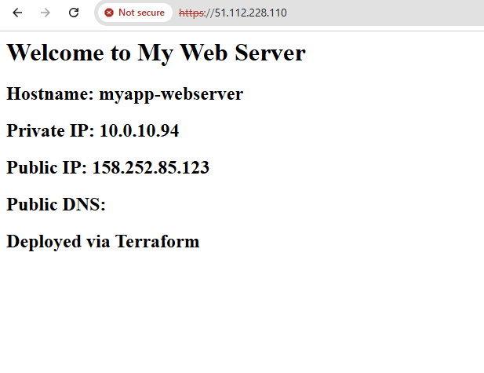

Task 9-Configure high availability with backup servers

- SSH into the webserver:
ssh ec2-user@<webserver-public-ip>

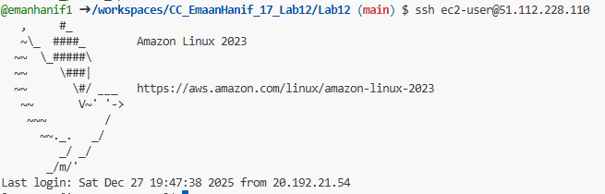

Configure web-1 as primary, web-2 as backup
sudo vim /etc/nginx/nginx.conf
Update upstream block:

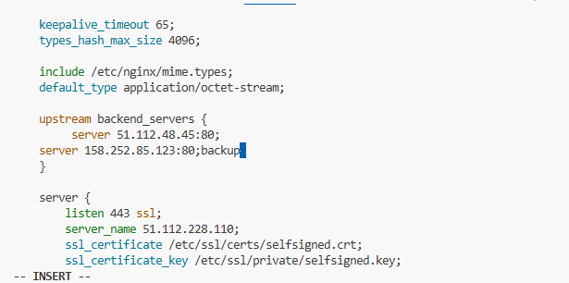

Restart Nginx
sudo nginx -t
sudo systemctl restart nginx
- Test in browser: https://<webserver-public-ip>
- Reload multiple times → only web-1 content
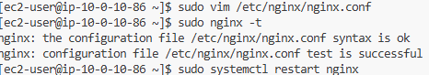

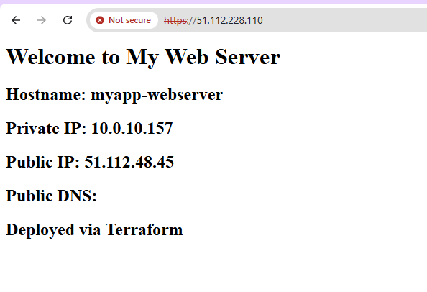

Switch to web-2 as primary, web-1 as backup
Edit again:
sudo vim /etc/nginx/nginx.conf
Update upstream:

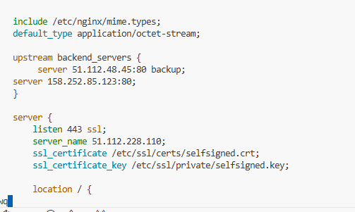

Restart Nginx
sudo nginx -t
sudo systemctl restart nginx
- Test in browser → reload multiple times → only web-2 content

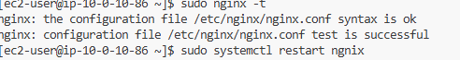

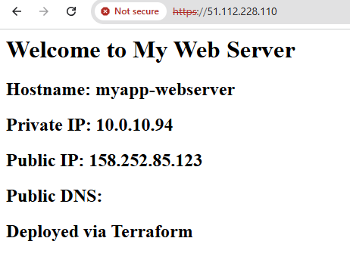

Task 10-— Enable Nginx caching
• SSH into the EC2 webserver using the public IP:
ssh ec2-user@<webserver-public-ip>

Opened the Nginx configuration file for editing:
sudo vim /etc/nginx/nginx.conf

- Made the necessary changes in nginx.conf to enable caching.
- Saved and exited the file after editing.
- Verified the changes to ensure Nginx caching was correctly configured.

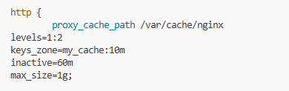
Defined a cache path /var/cache/nginx with keys_zone=my_cache:10m, inactive=60m, and max_size=1g.
- Configured log_format to track requests.
- Updated the server and location / blocks:
- Set proxy_pass to http://backend_servers.
- Enabled proxy_cache my_cache and proxy_cache_valid 200 60m.
- Added proxy_cache_key and add_header X-Cache-Status $upstream_cache_status.

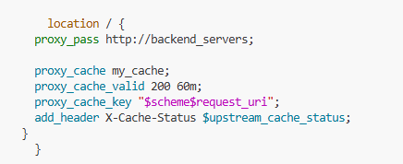

- Added an upstream block for backend servers: <web-1-public-ip> and <web-2-public-ip>.

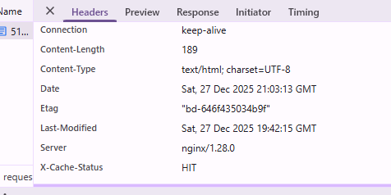

CLEANUP
- Exit SSH session:
exit
- Destroy all resources:
terraform destroy

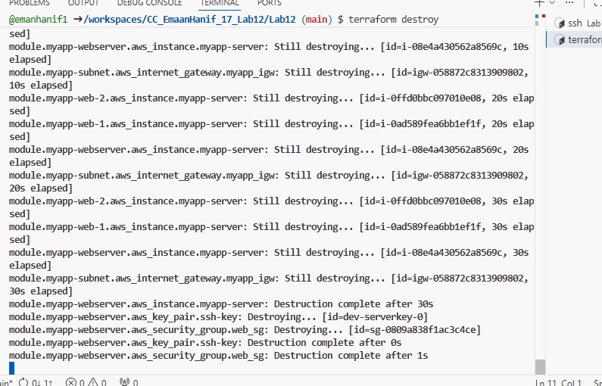

Destroy all resources

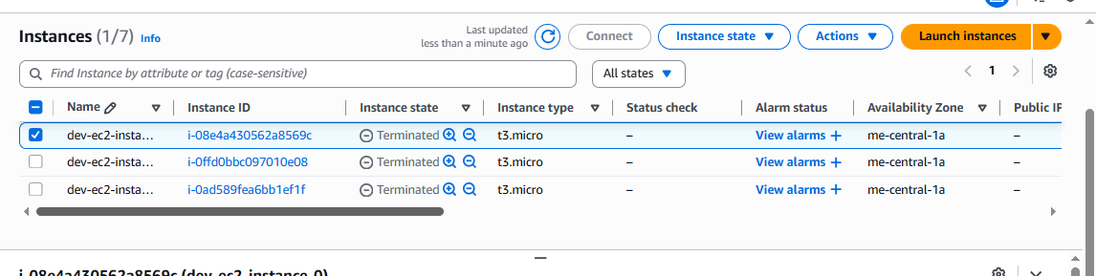
VERIFIED THAT NO RESOURCES RUNNING IN CONSOLE

